TITLE: TEMPLATE FOR PAPER SUBMISSION
(UPPERCASE, BOLD, Calibri 16)

Name^{1*}(Sentence case, Normal, Calibri 11)
¹Name of Institution (Sentence case, Normal, Calibri 11)
Email (Sentence case, Normal, Calibri 11)

Name²
²Name of Institution
Email

Please denote the corresponding author with an asterisk (*)

ABSTRACT (Centre, UPPER CASE, Bold, Calibri 12)

This document represents the required format for manuscript preparation for publication. By having a standardized format of submission, the editor and reviewers can make the assessment process with clarity. This template is to assist the author in familiarizing with the submission format and understanding the function of each section. On writing the actual abstract, it should be between 200 - 250 words in a single paragraph. It should be a concise summary that clearly outlines the paper’s rationale, methodology, findings, and contribution. The body text should be presented with justified alignment.

Keywords: Journal, Template, Guideline (To include a maximum of five keywords)

HEADING 1 (Align left, UPPERCASE, Bold, Calibri 12)

This template is constructed to assist authors in presenting their work so that it will be easy to be reviewed by the reviewers. Having a standard template will also assist in the eventual publication process should the paper is accepted. Submitting an article that is easier to be read by the reviewer will assist in expediting the review process.

This template was designed such that the author can substitute each section with one’s work accordingly and expand it as necessary. It includes samples of referencing and type formatting which is expected when submitting a manuscript in MS Word, which is the only acceptable format. The manuscript must not exceed 10,000 words excluding references and appendices. The manuscript also should meet the similarity index for less than 30%. The body text should be presented in a single paragraph with justified alignment.

HEADING 2 (Align left, UPPERCASE, Bold, Calibri 12)

Submitted an article should be structured in a way that follows a suitable journal publication style. The paper should be segmented with appropriate headings such as the following flow: Abstract, Introduction, Methodology, Results, Discussion/Conclusion, and References. However, the author may include other headings as deem necessary, such as Literature Review and Acknowledgement. The body text should be presented in a single paragraph with justified alignment.

SUBHEADING (Align left, UPPERCASE, Calibri 12)

Sub-heading may be inserted to improve the structure of the paper. This paragraph is an example of how a sub-heading. If required, a further hierarchical breakdown can utilise the subsection or bullet points. The body text should be presented in a single paragraph with justified alignment.

Subsections (Align left, Sentence case, Calibri 12)

This section is to illustrate format in the subsection. The text should be represented in single column with justified alignment. The body text should be presented with justified alignment.

FIGURES AND TABLES
Figures and tables are to be embedded in the main text body. They should not have cosmetic enhancement such as a shadow frame. One blank line separates the figure or table with the following text.
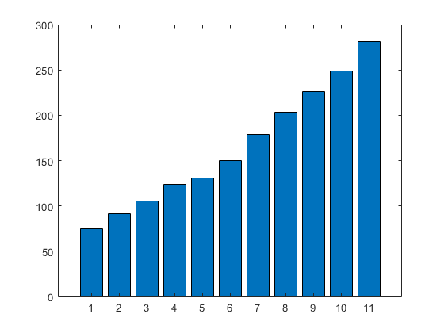
Figure 1. Each figure must be explained by a legend at the bottom using the same format as body text.

Table 1. Each table must be preceded with a label placed with sequence number and title using the same format as body text.
TYPE | CASE | FONT | SIZE | FORMAT | ALIGNMENT
HEADING | UPPER | CALIBRI | 12 | BOLD | CENTER
SUBHEADING | UPPER | CALIBRI | 12 | NORMAL | CENTRE
Subsection | Sentence | CALIBRI | 12 | NORMAL | CENTRE

REFERENCES
American Psychological Association. (2010). Mastering APA style: Student's workbook and training guide (6th ed.). Washington, DC: American Psychological Association.

